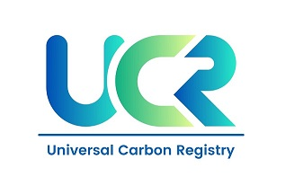
PROJECT CONCEPT NOTE
CARBON OFFSET UNIT (CoU) PROJECT
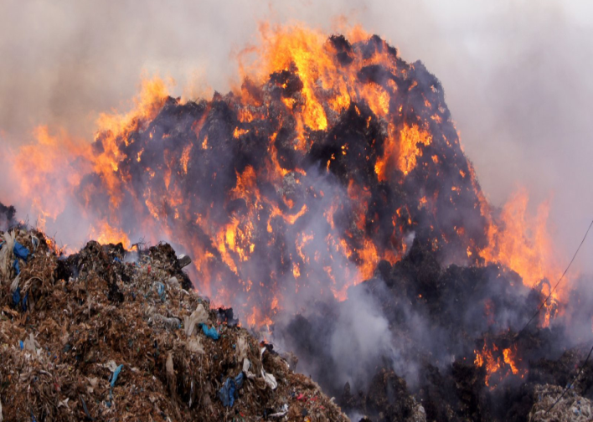
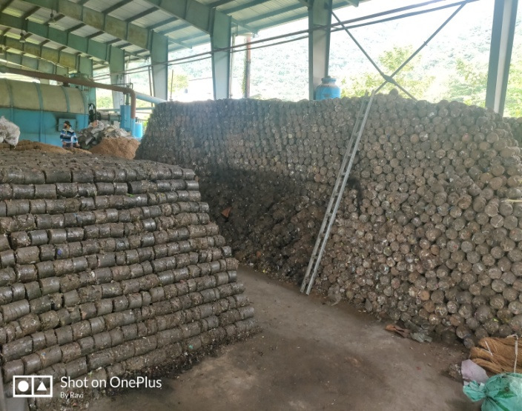

Title: Lamdeng Waste to Energy Project, Manipur
Version 1.0
Date 23/10/2021
First Issuance Period: 5 years, 10 months
Crediting Period: 01/01/2016 to 31/10/2021

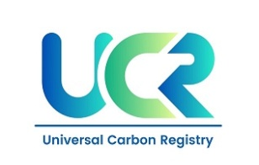
Project Concept Note (PCN)
CARBON OFFSET UNIT (CoU) PROJECT
BASIC INFORMATION
Title of the project activity | Lamdeng Waste to Energy Project, Manipur
Scale of the project activity | Small Scale
Completion date of the PCN | 23/10/2021
Project participants | IEC-TSL Ingenious Energy LLP, Ahmadabad
Host Party | India
Applied methodologies and standardized baselines | Small-scale Methodology  AMS.I.D. Grid connected renewable electricity generation  UCR Protocol Standard Baseline  AMS-III.E Avoidance of methane production from decay of biomass through controlled combustion, gasification or mechanical/thermal treatment
Sectoral scopes | 01 Energy industries (Renewable/NonRenewable Sources)  13 Waste handling and disposal
Estimated total average GHG emission reductions | 71036 CoUs (71036 tCO_{2eq})

SECTION A. Description of project activity

A.1. Purpose and general description of Carbon offset Unit (CoU) project activity >>

The project Lamdeng Waste to Energy Project, Manipur is located at Village: Lamdeng, District: Imphal West, State: Manipur, India.

The details of the registered project are as follows:

Purpose of the project activity:
The Lamdeng Waste to Energy Project, Manipur is located at Village: Lamdeng, District: Imphal West, State: Manipur, India. The plant has been functioning under the Public-Private Partnerships (PPP) model since December 15, 2016. Imphal district produces about 120 tonnes of waste per day and a number of processes are involved in effectively managing this waste. It includes monitoring, collection, transport, processing, recycling and disposal.

The project activity is spread across an area of 12 acres. The entire process of waste management includes usage of machineries like the JCB's, tractors and processing and refining machines. This venture has also helped generate employment opportunities for many in the city. Currently, the plant employs 19 people.

The project proponent has already commissioned this 120 tonne-per-day (TPD) municipal solid waste (MSW)-to-energy project in Imphal, Manipur. The processed solid waste currently generates 600KW_{h}of electricity, which is supplied to the grid and has been doing so since April 2021. This project activity comprises measures that avoids the GHG emissions from methane (CH₄) from biomass or other organic matter that would have otherwise been left to decay under anaerobic conditions throughout the crediting period in a solid waste disposal site without methane recovery. Since April 2021, the entire generation of RDF has been put through gasification to generate electricity and supplied to the local grid, thus displacing electricity that would be provided to the grid by more-GHG-intensive means. Hence the project activity avoids CH₄ and CO₂ emissions and is beneficial to the environment and community.

Between 2016 and April 2021, the MSW was treated by mechanical treatment to produce refuse-derived fuel (RDF)/stabilized biomass (SB). This RDF was transported outside the project boundary and supplied as renewable fuel to replace fossil fuel at various industries.

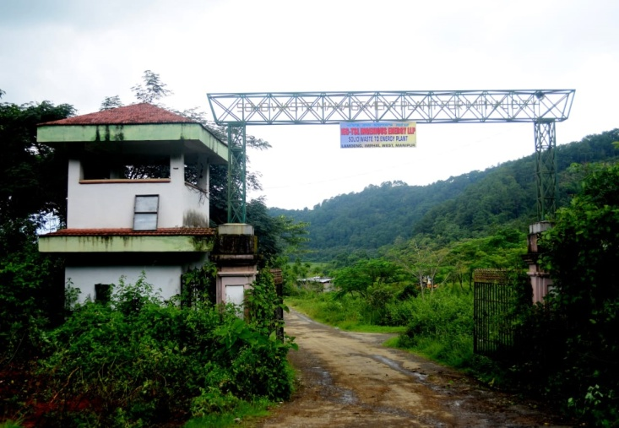
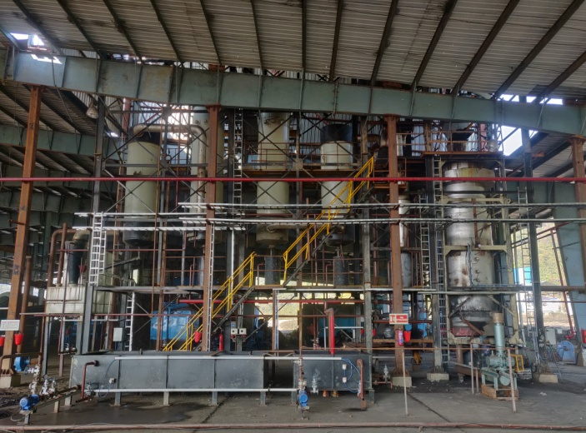

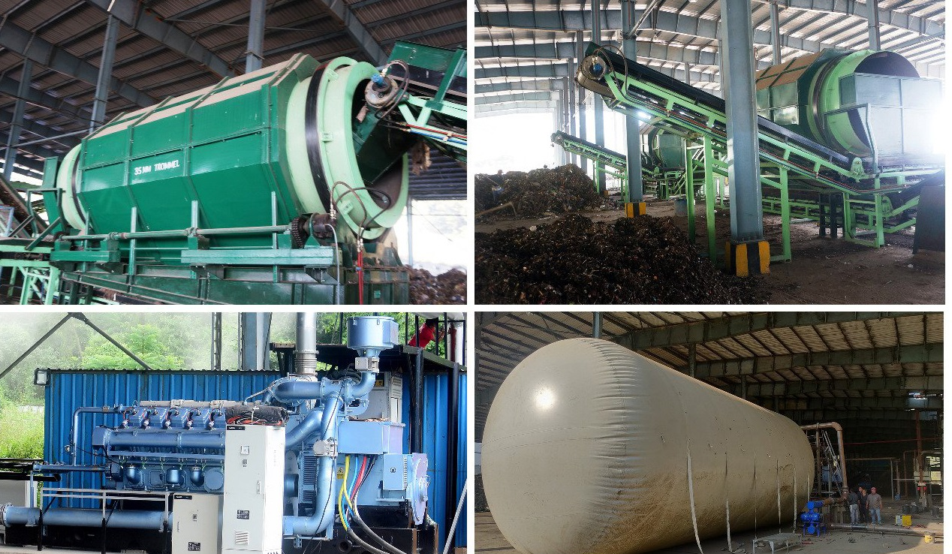
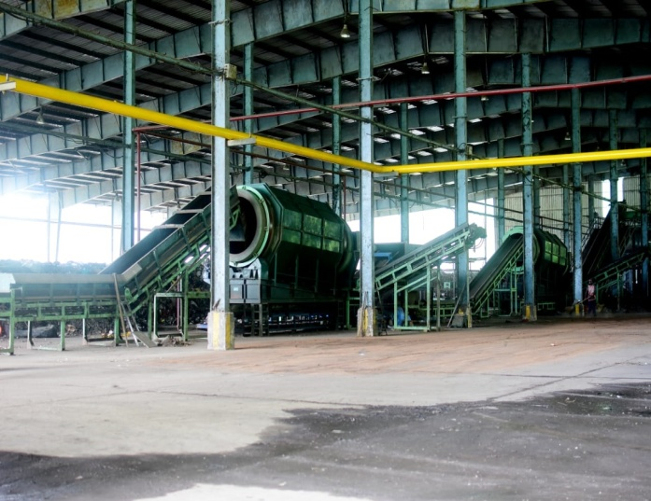
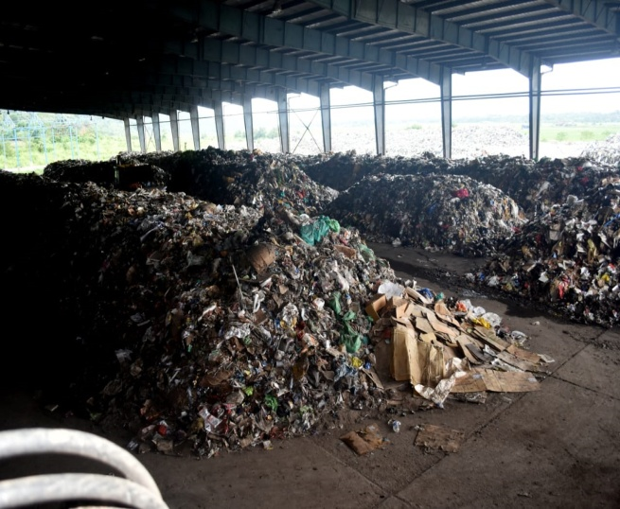
MSW starts out as a complex mixture of food waste, glass, metals, yard trimmings, woody waste materials, non-recyclable paper and plastic, construction and demolition waste, rags, and sludge from wastewater treatment. MSW presents numerous challenges when used as a feedstock for energy production: it has low energy content, high moisture, heterogeneous composition, and despite its abundance—it is highly distributed across India making it difficult for traditional approaches to reach economies of scale in many parts of the country. In December 2019, the Union Power Minister R.K.Singh told the Indian Parliament that to recover energy from waste and effluent generated from industries, India has set up 186 waste-to-energy projects for the generation of biogas, bio CNG with a cumulative capacity of 317.03 MW. Out of the 186 projects, five projects are based on MSW, thus generating a total capacity of 66.5 MW of energy.
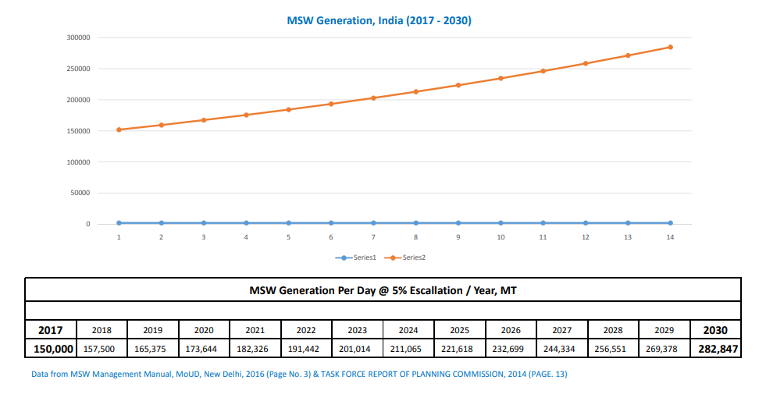
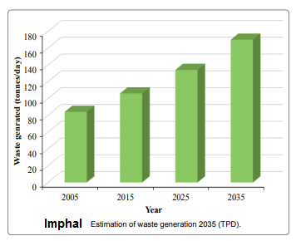
In the absence of sanitary landfills, solid wastes (SWs) get dumped in the open places, creating nuisance and unhygienic conditions. This has resulted in a high risk of contamination to different environmental compartments including soils, groundwater/surface water, and air leading towards human health hazards.
The newly proposed future strategies and action plans by Imphal Municipal Corporation to combat the deficiencies in the existing MSW systems will only prove to be satisfactory and feasible it its ability to expand keeps pace with the MSW being being generated. In India, the per capita generation of MSW has increased from 0.44 kg/day in 2001 to 0.5 kg/day in 2011. The increase in purchasing power of urban Indians in addition to the growing population, urbanization and industrialization has resulted in 50% increase of MSW generated in the last decade. The urban cities of India generate about 68.8 million tons per year or 188, 500 tons per day of MSW. The steep increase of MSW generation has worsened the severity of stress on all available resources such as natural, infrastructural and budgetary (Annepu, 2011). The situation has alarmed NGOs, civil societies and other stakeholders to take part in effective management of MSW in various cities of India. At present, the MSW from Imphal is dumped in Porompat and Langol landfill sites.
Further an added revenue source from the sale of carbon credits will allow increased adoption of similar systems all over the country. The municipal solid waste (MSW) management in Imphal is still infused with challenges owing to the predominant reliance on the conventional method of waste collection, transportation and disposal. Segregation of waste is not done at source even though the municipal laws stress the importance of it. The situation at present is alarming and requires improvement in the area of infrastructural up gradation, public-private partnership (PPP), public participation, awareness campaign and implementation of existing laws. The reliance on modern method of waste recovery and recycling in the present context of waste management is negligent.

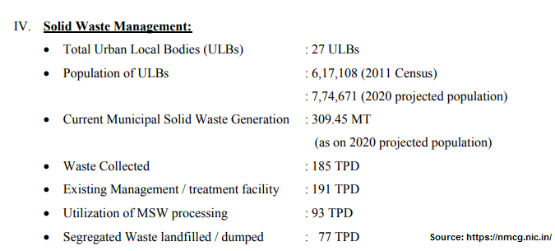
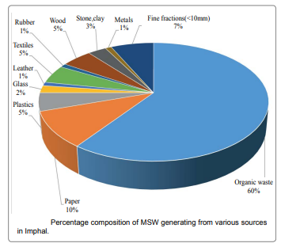

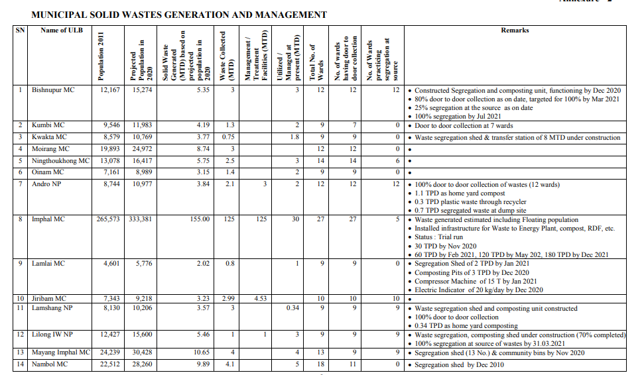

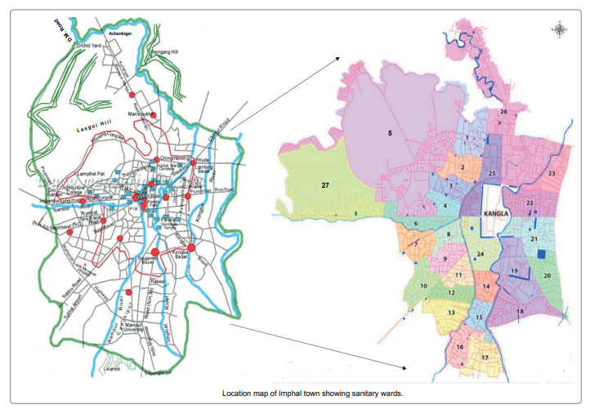
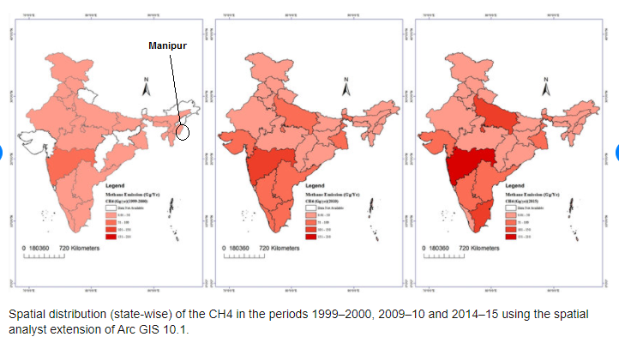

A.2 Do no harm or Impact test of the project activity>>
There are social, environmental, economic and technological benefits which contribute to sustainable development.
- Social benefits:
- The project contributes in improving the environmental condition in the region of by hygienic treatment of MSW resulting in improvement of health standard in the city.
- The project provides employment opportunity to the locals who sort can collect the recyclables from the plant and ensure that only organic waste is treated.
- The project would provide both direct and indirect employment opportunity to the people of the region.
- Reduces outdoor air pollution, thus eliminating health hazards for traders in the vicinity.
- The project provides security of energy supply since it generates renewable electricity
- It leads to better waste management thus keeping the surroundings clean and reduce some of the disease causing pathogens.
- The population of Imphal are prone to various diseases like Respiratory infection, Hepatitis, Cholera, Dysentery and Typhoid etc, due to uncontrolled MSW disposal, the project activity helps reduce such illnesses.

- Environmental benefits:
- Curbs methane emission as well as any leachate that would otherwise have been generated from the current practice of unscientific waste disposal.
- The land requirement used for a disposal site is removed as also is the area for dumping of equivalent amount of waste. This indirectly enables the region to move towards a better way of land utilisation, like construction of housing, hospital etc.
- Further, by generating electricity, the project helps in replacing fossil fuel intensive power generation from the local grid.
- Avoids local environmental air pollution through better waste management
- All the waste generated in the surrounding area used to dumped in open landfills unscientifically, leading to acute shortage of land fill site near the city. The project activity involves the processing of municipal solid waste and generation of power.

- Economic and Technological benefits:
- The project activity contributes in terms of streamlining the collection and segregation of MSW before further treatment and increases the chances of recovery of products that can be reused and recycled.
- Provides employment to local communities through construction, maintenance of MSW and electricity units.
- It also helped in creating hygienic working and environment conditions for the locals engaged in waste collection and segregation from the dumping site.
- The revenue from carbon credits will showcase such efforts undertaken to make MSW to energy projects environmentally sustainable and rewarding. Further using carbon revenue, the project proponent can provide incentives to households to segregate the waste at the source and in return earn tokens or tax credits.
- Funds from the sale of carbon credits will be used for upgrading the power generation capactiy. Further, the revenue from carbon credits can also be used to aquire land for expansion due to the rate of population growth in the city and the amount of MSW expected to be generated, since additional land requirement for MSW disposal in Imphal town is estimated at 171 acres by 2035 (source: International Journal of Waste Resources , 2016, Municipal Solid Waste Management in Imphal Town, Northeast India: A Critical Analysis of Existing Management Practices and Proposed Action Plans).

A.3. Location of project activity >>
Country: India.
District: Imphal West
Village: Lamdeng
State: Manipur
Code: 795001
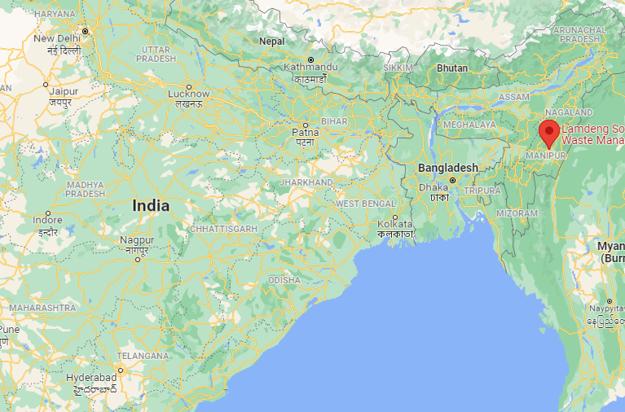
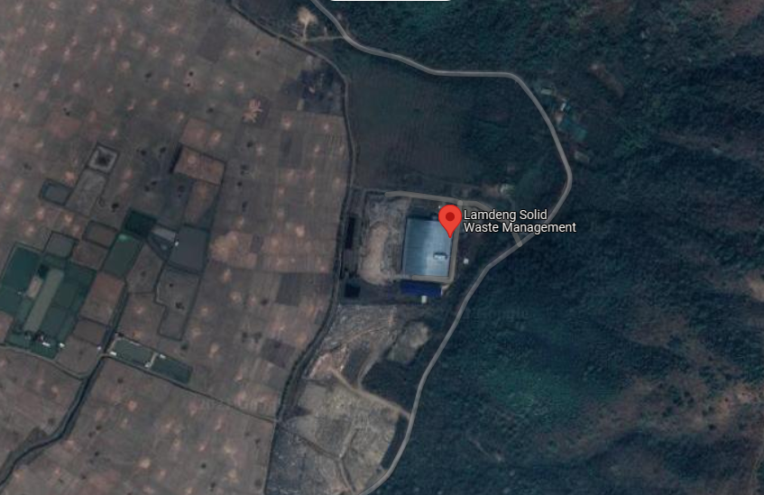

A.4. Technologies/measures >>

Preprocessing of MSW is primarily intended to remove large debris and large objects of inerts that are typical of littering culture in Manipur and India. Incoming MSW from the city using trucks is unloaded on tipping floor. A trammel is placed to screen out stones, accompanying silt as it induces a gyratory movement for the MSW as it tumbles and cascades down the trammel. It involves manual and mechanical sorting further to remove plastics, rubber and leather and large metal objects. The speed of the belt carrying the MSW is variable to permit the same with ease. Incoming MSW from the city using trucks is unloaded on tipping floor.

Before shredding, the incoming MSW is inspected on the horizontal conveyer and odd objects like big inert pieces, wooden pieces, long iron pieces etc. are hand picked and removed. Residue generated prior to primary shredding of MSW is mostly inert material as well as segregated material like rubber, large debris emanating from construction and large biomass objects.

Rubber is recycled while other inert matter is discarded to dump yard. After inspection, it is pushed on the slat conveyor for primary shredding. In primary shredding, MSW is delumped in to small sizes to enable easy drying and separation. Delumped MSW is dried to reduce the moisture content in the drying yard/shed.

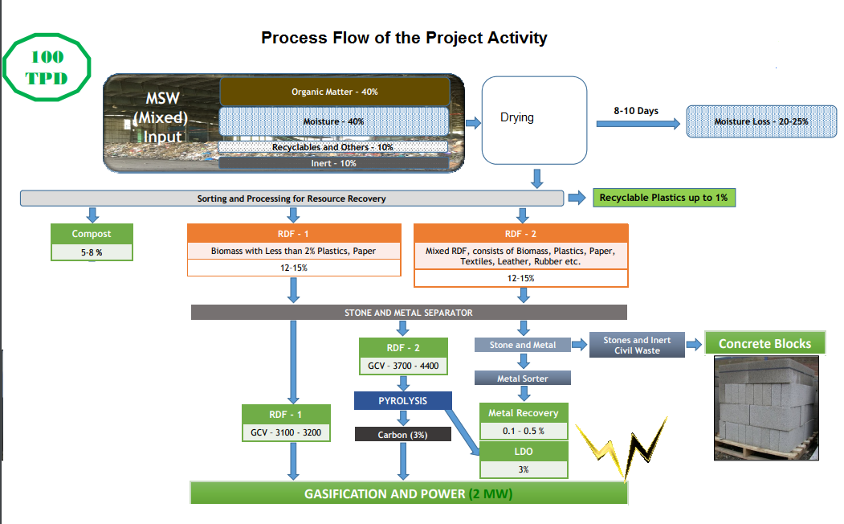

The project activity processes the MSW and generates RDF which is combusted as the main fuel in the specifically designed gasifier to produce syngas. All the syngas produced, which may contain non-CO2 GHG, is combusted and not released unburned to the atmosphere. Measures to avoid physical leakage of the syngas between the gasification and combustion sites is already adopted. The syngas passes through the generator set to generate power and is connected to the local grid for direct electricity export. RDF firing energy plant facilities are complex and regardless of size, call for specialized design, automatic control sophistication and construction. Materials handling, fuel feeding, ash removal, air pollution control and overall operating procedures are far more complicated than those of a similarly sized biomass based power plant. In RDF firing, the garbage/MSW received is separated, classified and reclaimed in various ways to yield high calorific value fuel. The combustion of RDF poses its own set of unique problems to a boiler designer in the areas like fuel handling system, combustion, staging/fouling and corrosion/erosion, which can be quite different from those, encountered in a mass burn boiler system.

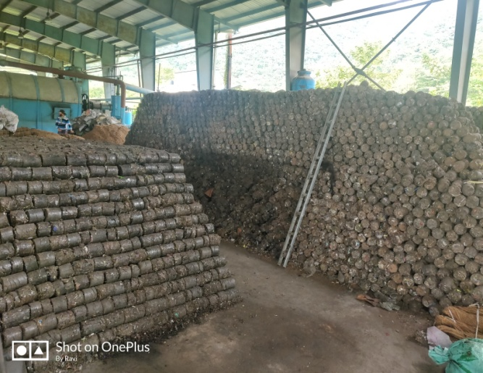
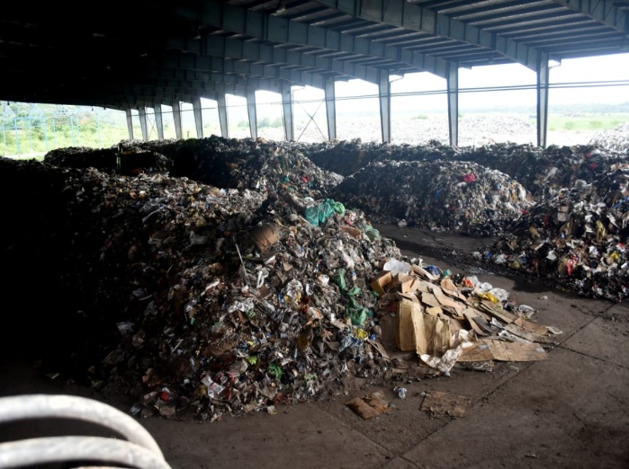
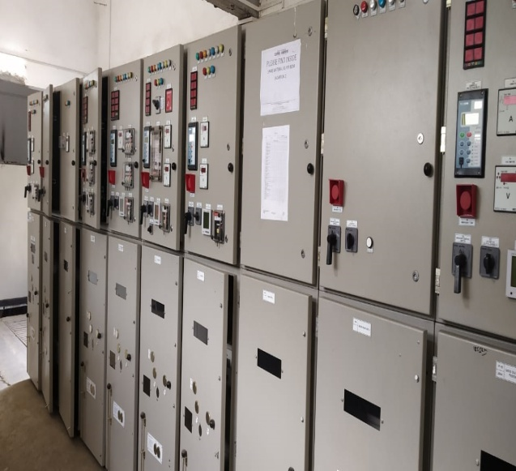
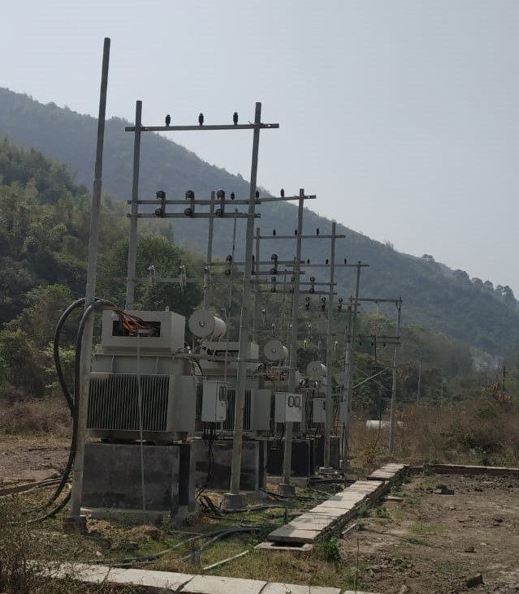
A.5. Parties and project participants >>

Party (Host) | Participants
India | IEC-TSL Ingenious Energy LLP, A-103, Sagun Plaza, Vastrapur, Ahmadabad - 380015

A.6. Baseline Emissions>>
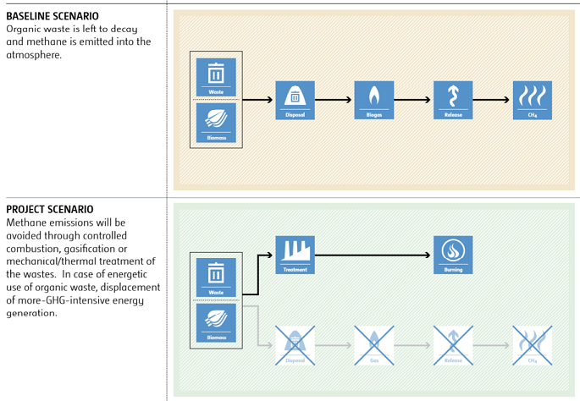
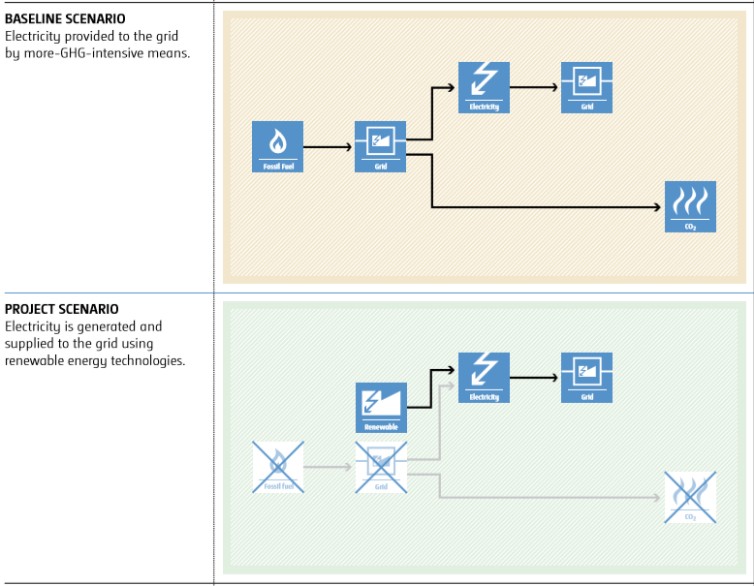

The baseline scenario identified at the PCN stage of the project activity is:

- avoidance of methane emissions due to prevention of anaerobic decay of biomass in waste.

- displacement of electricity that would be provided to the grid by more-GHG-intensive means.

A.7. Debundling>>
This micro scale project is not a debundled component of a larger project activity.

SECTION B. Application of methodologies and standardized baselines

B.1. References to methodologies and standardized baselines >>

SECTORAL SCOPE - 01 Energy industries (Renewable/Non-renewable sources)
13 Waste handling and disposal

TYPE I - Renewable Energy Projects

CATEGORY- AMS-I.D. Grid connected renewable electricity generation

This category comprises renewable energy generation units, such as renewable biomass, that supply electricity to and displace electricity from an electricity distribution system that is supplied by at least one fossil fuel fired generating unit.

AMS-III.E . Avoidance of methane production from decay of biomass through controlled combustion, gasification or mechanical/thermal treatment

Decay of the wastes that would have been let to decay or are already deposited in a waste disposal site is prevented through gasification to produce syngas/producer gas; or mechanical/thermal treatment to produce refuse-derived fuel (RDF) or stabilized biomass (SB).

B.2. Applicability of methodologies and standardized baselines >>

Project activity involves the combustion of processed solid waste material to generate heat to produce steam for power generation. This does not involve recovery nor combustion of methane directly.
The produced RDF/SB was used for combustion off-site till April 2021 and then for grid power supply since that time.
Measures are limited to those that result in emission reductions of less than or equal to 60 kt CO2 equivalent annually under AMS III. E.
Prior to gasification, the thermal treatment process (dehydration) of MSW occured under controlled conditions (up to 300 Celsius) and generated a stabilized biomass that was used as fuel material in other off-site industrial processes.
Project activity involves the avoidance of methane generation from MSW landfill sites through controlled combustion of processed MSW in boiler to produce electricity. In the absence of project activity, MSW in the landfill sites would have left to decay anaerobically and led to methane generation.
The annual average temperature of the biogas site is located is higher than 5°C
Stabilized biomass (SB) is refuse derived fuel (RDF) briquettes.
As the project activity involves both avoidance of methane and subsequent generation of electricity through controlled combustion and supply of power to grid, the project activity is also eligible under small scale methodology AMS I.D.
The power generation capacity of the plant is less than eligible limit of 15 MW, the project is eligible under AMS I.D small scale category. The project does not co fire any fossil fuel for power generation.
Measures are limited to those that result in emission reductions of less than or equal to 60 kt CO2 equivalent annually
In case of RDF/SB processing, the produced RDF/SB is not stored in such a manner as resulting in high moisture and low aeration favouring anaerobic decay

B.3. Applicability of double counting emission reductions >>

All the units are constructed within the project boundary. Each unit has a unique ID, which is visible. The Monitoring Report has the details of the details and unique meter reading ID.

B.4. Project boundary, sources and greenhouse gases (GHGs)>>
The project boundary are the physical, geographical sites:
(a) Where the solid waste is deposited and the avoided methane emission occurs in absence of the proposed project activity;
(b) Where the treatment of biomass through controlled combustion, gasification or mechanical/thermal treatment takes place;
(c) Where the final residues of the combustion process will be deposited (this parcel is only relevant to controlled combustion activities);
  - (a) All plants generating electricity at the project site,
  - (b) Industrial, commercial or residential facility, or facilities, consuming energy generated by the system and the processes or equipment affected by the project activity;

 | Source | GHG | Included? | Justification/Explanation
 | Emissions from biomass decay  Baseline  Emissions from electricity generated using fossil fuels | CO₂ | Included | Major source of emission
 |  | CH₄ | Included | Major source of emission
 |  | N₂O | Excluded | Excluded for simplification. This is conservative
 | Project Activity  Emissions from RDF transport off site | CO₂ | Included | Minor source of emissions
 | Project Activity  Emissions from RDF transport off site | CH₄ | Excluded | Excluded for simplification. This is conservative
 | Project Activity  Emissions from RDF transport off site | N₂O | Excluded | Excluded for simplification. This is conservative

Leakage:
In case of RDF/SB production, project proponents will demonstrate that the produced RDF/SB is not subject to anaerobic conditions before its combustion end-use resulting in methane emissions.

Between 2016 and April 2021, the produced RDF/SB was not used in captive facilities but sold to consumers outside the project boundary as a fuel, hence as a default, 5 per cent of the baseline emissions shall be deducted as leakage to account for these potential methane emissions and in efforts to be conservative in the baseline estimates.

The project activity recovers and utilizes methane for producing electricity and applies this methodology in addition to using a Type III component of a SSC methodology, hence any incremental emissions occurring due to the implementation of the project activity from April 2021 is neglected.

B.5. Establishment and description of baseline scenario (UCR Protocol) >>

The baseline scenario is the situation where, in the absence of the project activity, organic waste matter is left to decay within the project boundary and methane is emitted to the atmosphere. The yearly baseline emissions are the amount of methane that would have been emitted from the decay of the cumulative quantity of the waste diverted or removed from the disposal site, to date, by the project activity, calculated as the methane generation potential using the “Tool to determine methane emissions avoided from disposal of waste at a solid waste disposal site”.

For renewable energy technologies that displace technologies using fossil fuels, the simplified baseline is the fuel consumption of the technologies that would have been used in the absence of the project activity, times an emission factor for the fossil fuel displaced. The project proponent was not bound to incur this investment as it was not mandatory by national and sectoral policies. Thus, the continued operation of the project activity would continue to replace fossil fuel derived grid electricity.

In the case of project activities combusting, gasifying or mechanically/thermally treating only freshly generated wastes, the baseline emissions at any year y during the crediting period is calculated using the amount and composition of wastes combusted, gasified or mechanically/thermally treated since the beginning of the project activity (year “x=1”) up to the year y, using the first order decay model as referred to in the “Tool to determine methane emissions avoided from disposal of waste at a solid waste disposal site”.

Estimated Annual Emission Reductions: BE_{y} = BE_{y1} + BE_{grid}-PE_{y,transport}

BE_{y} = Total Baseline Emissions in a year.
BE_{grid} = EG _{y,grid} x EF _{y,grid}

BE_{grid} | = | Baseline emissions for the grid electricity displaced by the project in year y (t CO2e)
EG _{y,grid} | = | Amount of grid electricity displaced by project in year y (MWh)
EF _{y,grid} | = | Emission factor of the grid (t CO2e/MWh) = 0.9 (UCR Standard)

BE_{y1}= Yearly Methane Generation Potential of the wastes diverted to be disposed in the landfill from the beginning of the project (x=1) up to the year y

Be_{y1} = MB,y * GWP_CH4
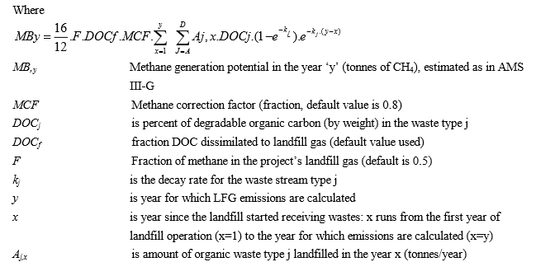

GWP_{CH4} | = | 21 is the default IPCC value of CH₄ applicable to the crediting period (tCO_{2e}/t CH₄)
MCF | = | 0.8 For projects utilising MSW, when calculating BE_{CH4,SWDS,y,} . Deep landfill (>5m) is most likely the technology for disposing MSW in the scenario of constrained availability of area/space within or close to urban areas and where waste scavenging does not occur. And it is also the least cost alternative for providing comparable level of service to the project technology for treating the waste i.e. composting in this case. MCF value is chosen from the definition provided in 2006 IPCC Guideline applicable to unmanaged deep landfills that do not have controlled placement of waste (i.e. waste directed to specific deposition areas, a degree of control of scavenging and a degree of control of fires) and do not include any cover material, mechanical compacting and levelling of the waste

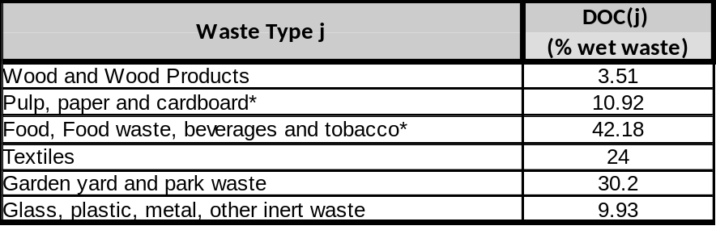

Project Emissions

Project emissions consist of:
Project Emissions due to burning of plastics (non – biomass fuels) & auxiliary fuels fossil fuels used in the combustion, gasification or mechanical/thermal treatment facility is negligible and not estimated.

Incremental CO₂ emissions due to:

        - Between 2016-April 2021: Transportation of RDF/SB to the sites of the end users (since outside sites are unknown a conservative approach assuming transport emissions for a specific distance, for example a default of 250 km, shall be used as per the AMS methodology);

PE_{y,transport} = Emissions due to the transport of RDF from processing plant to customers outside facility
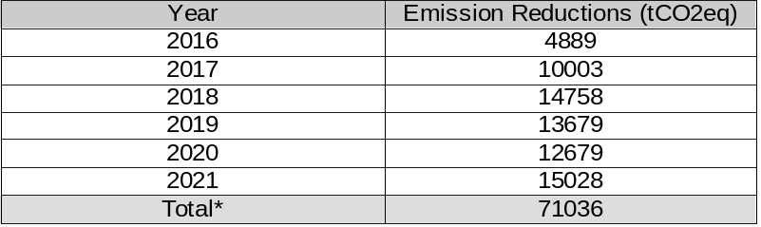

*Estimate of total. During verification, a deduction of 5 per cent of the baseline emissions shall be taken into account as to include leakage project emissions for potential methane emissions during the transport of the RDF offsite between 2016 and 2020 and in efforts to be conservative in the baseline estimates, unless during verification the project proponent can showcase to the UCR auditor that potential risks of methane emissions from RDF/SB are avoided through measures such as appropriate packaging or, by showing that monitored moisture content of the RDF/SB is under 12 per cent.

B.6. Prior History>>
The project activity has not applied to any other GHG program for generation or issuance of carbon offsets or credits.

B.7. Changes to start date of crediting period >>
There is no change in the start date of crediting period.

B.8. Permanent changes from PCN monitoring plan, applied methodology or applied standardized baseline >>
There are no permanent changes from registered PCN monitoring plan and applied methodology

B.9. Monitoring period number and duration>>

First Issuance Period: 5 years, 10 months – 01/01/2016 to 31/10/2021

B.8. Monitoring plan>>

The amount of waste combusted, gasified or mechanically/thermally treated by the project activity in each year (Qy) shall be measured and recorded, as well as its composition through representative sampling, to provide information for estimating the baseline emissions.

Data/Parameter | Date of commissioning of units
Data unit | Date.
Description | Actual date of commissioning of the project units
Source of data  Value(s) applied | Monitoring Report  As and when commissioned
Measurement methods and procedures | The construction processes are maintained from its initiation to completion dates for the biogas unit. Thus the start date of each of the unit installed is recorded in the monitoring report.
Monitoring frequency | As and when commissioned and fixed and recorded in the monitoring report
Purpose of data | To estimate baseline emissions

Data / Parameter: | Q _{waste}
Data unit: | tons
Description: | Quantity of solid waste or residual waste
Source of data: | Measured
Measurement  procedures (if any): | On-site data sheets recorded monthly using weigh bridge
Monitoring frequency: | Monthly-
QA/QC procedures: | Quantity of waste processed in the plant is measured using the weigh bridge at the entrance of the plant. Weigh bridge is calibrated on regular basis as per the procedures of Department of Weighs and Measurements
Any comment: | -

Data / Parameter: | N_{y}
Data unit: | Number of operational days in a year
Description: | Measured
Source of data: | -
Measurement  procedures (if any): | Records kept in the log book.
Monitoring frequency: | Annually, based on monthly records
QA/QC procedures: | -
Any comment: | -To estimate baseline emissions

Data / Parameter: | W_{j}
Data unit: | %
Description: | Percentage of waste type entering the MSW facility
Source of data: | -
Measurement  procedures (if any): | Sampling in log book.
Monitoring frequency: | Annually, based on monthly/daily records
QA/QC procedures: | -
Any comment: | To estimate baseline emissions

Data / Parameter: | EG_{grid,y}
Data unit: | MWh
Description: | Quantity of electricity supplied to the grid
Source of data | Plant meter records
Measurement  procedures (if any): | Measured using calibrated meters. Calibration shall be as per the relevant methodologies.
Monitoring frequency: | Continuous monitoring, integrated hourly and at least monthly recording
QA/QC procedure | -
Any comment: | The parameter need to be monitored for project activities which displaces grid electricity

Data / Parameter: | EF_{grid,y}
Data unit: | t CO₂e/MWh
Description: | CO₂ emission factor for the grid electricity in year y
Source of data | -
Measurement  procedures (if any): | As described in UCR Standard
Monitoring frequency: | Annual
QA/QC procedure | -
Any comment: | The parameter need to be monitored for project activities which displaces grid electricity

Data / Parameter: | N_{y,trucks}
Data unit: | Number of trucks used between 2016-2020 for RDF transport offsite
Description: | RDF was transported offsite during the years 2016-2020.
Source of data: | -
Measurement  procedures (if any): | Records kept in the log book.
Monitoring frequency: | Annually, based on monthly records
QA/QC procedures: | -
Any comment: | -To estimate project emissions

